Assignment 2

CSCI E-57

Nathan Hunt

15 November 2020 (extended to 22 November 2020)

Assignment 2 execution instructions

2.1:

Prerequisite: running the following in MySql:

1. resources/db/ddl.sql
2. resources/sql/schema.sql
3. resources/sql/test-data.sql

Also, running mvn clean install

* find all books by category name:
  + java -jar target/assignment2_1-find-books-by-category-name.jar
  + Expected output:

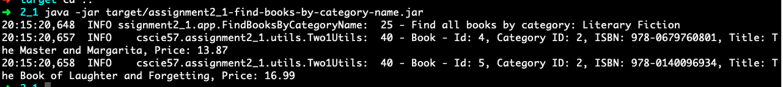

* find all categories:
  + java -jar target/assignment2_1-find-all-categories.jar
  + expected output:

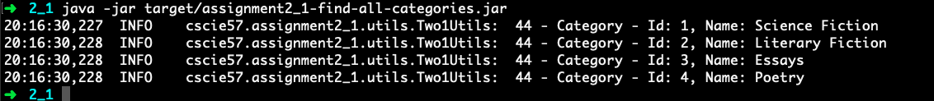

* find all books:
  + java -jar target/assignment2_1-find-all-categories.jar
  + expected output:

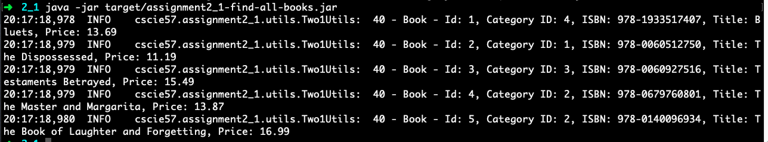

* insert a new book with existing category id:
  + java -jar target/assignment2_1-insert-new-book.jar
  + expected output:

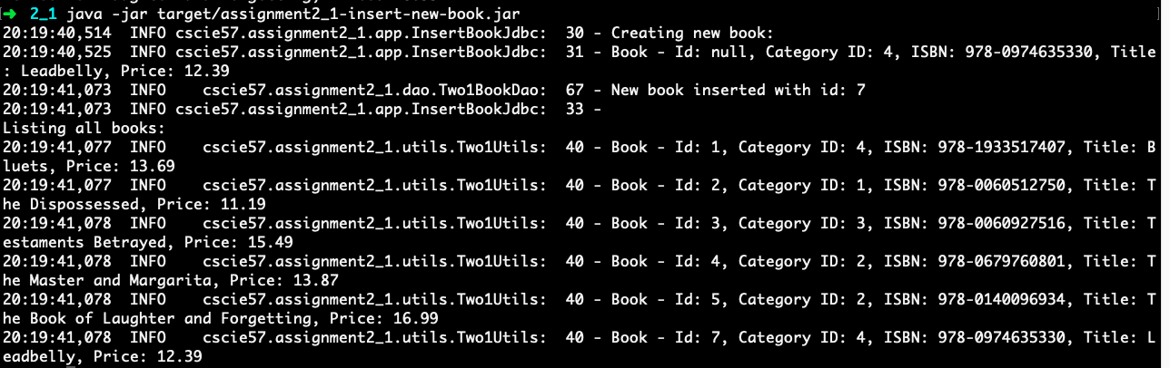

* find book with id=6. Update the book’s price, setting it to 39.99:
  + java -jar target/assignment2_1-update-book-price.jar
  + expected output:

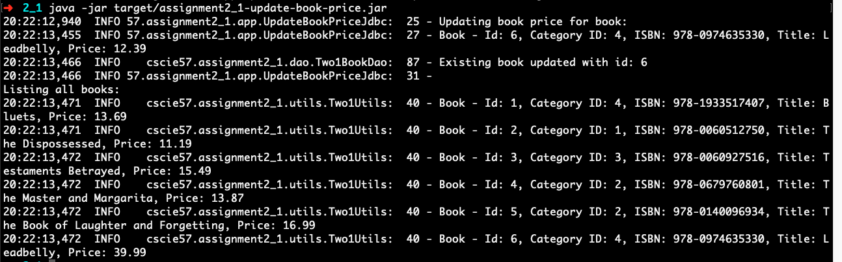

* delete the book with id=6:
  + java -jar target/assignment2_1-delete-book.jar

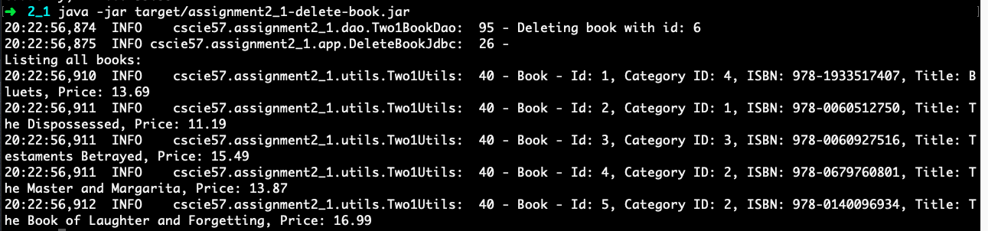

2.2:

Prerequisite: running the following in MySql:

1. resources/db/ddl.sql
2. resources/sql/schema.sql
3. resources/sql/test-data.sql

Also, running mvn clean install

* find all books without authors and categories:
  + java -jar target/assignment2_2-find-all-books.jar
  + expected output:

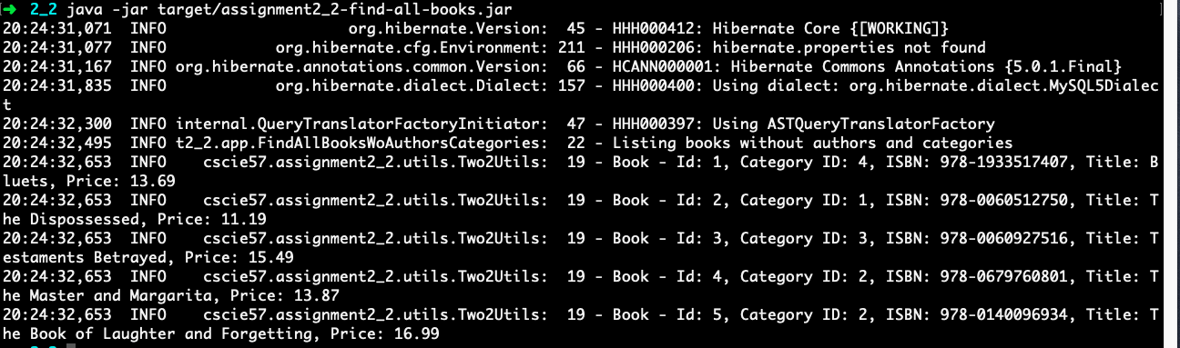

* find all books with authors and categories:
  + java -jar target/assignment2_2-find-all-books.jar
  + expected output (partial):

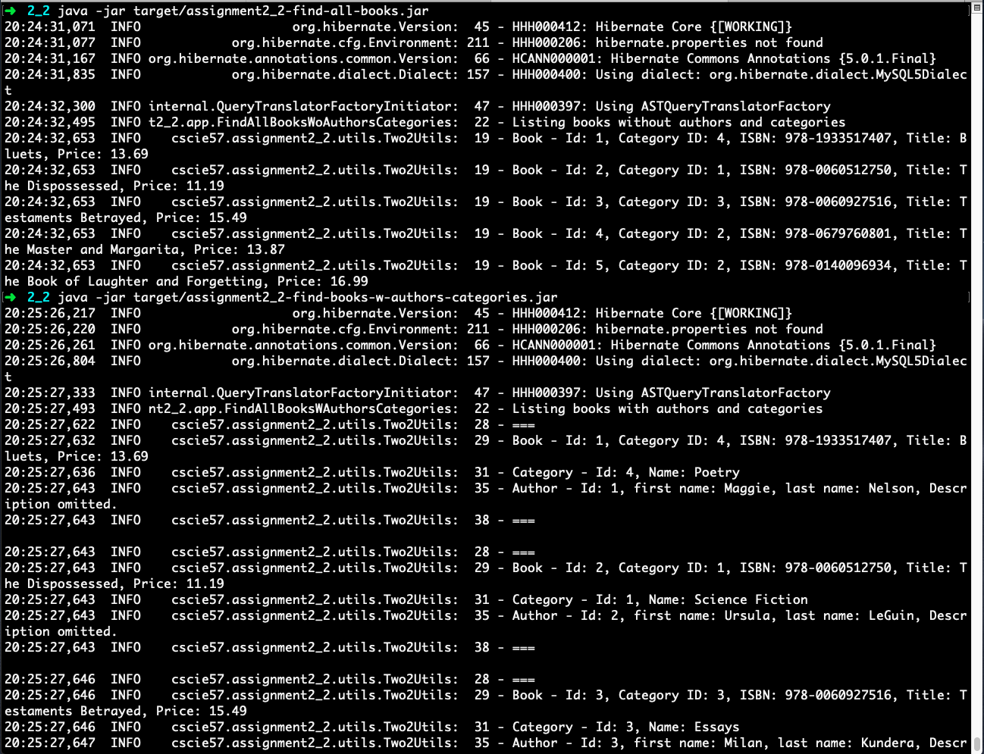

* find a book with authors and category by book’s ID
  + java -jar target/assignment2_2-find-book-by-id-w-authors-categories.jar
  + expected output:

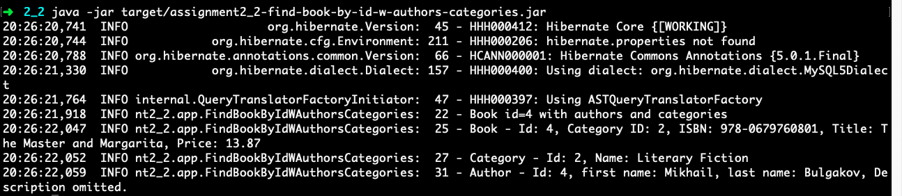

* find all books by author id
  + java -jar target/assignment2_2-find-book-w_categories-by-author-id.jar
  + expected output:

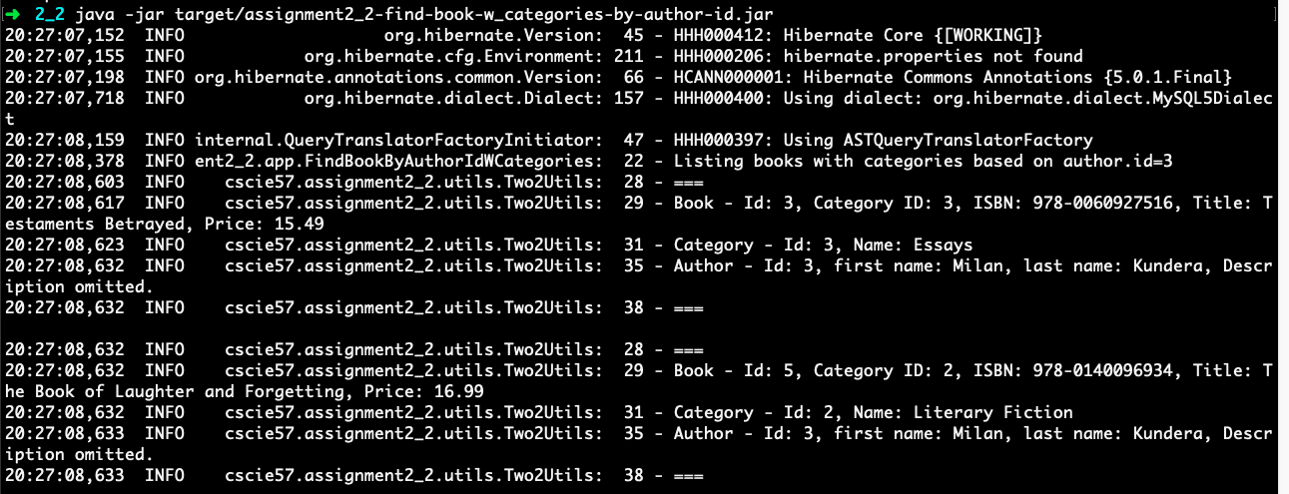

* create a new book with a new author not persisted yet in your database:
  + java -jar target/assignment2_2-create-new-book-author.jar
  + expected output:

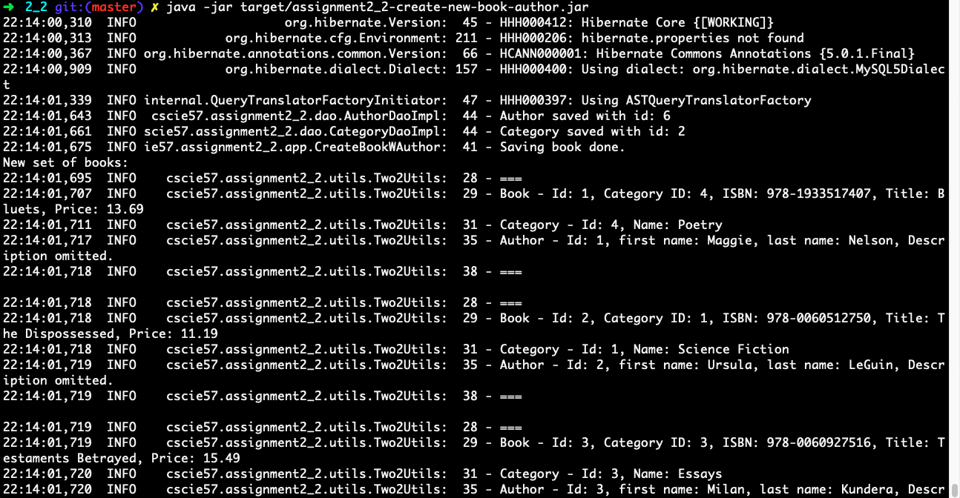

* delete the saved book and author from the database
  + java -jar target/assignment2_2-delete-book-author.jar
  + expected output:

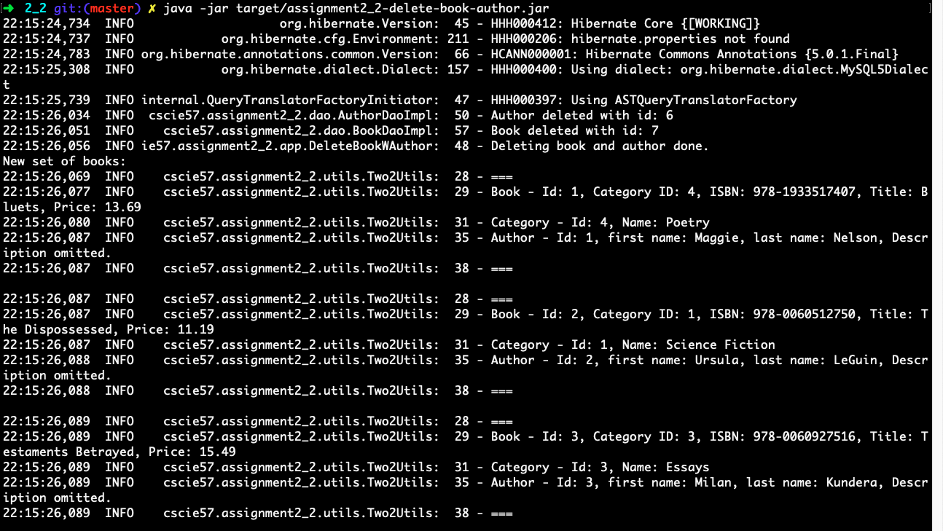

2.3:

Prerequisite: none for MySQL (reuses database from 2.2). Running mvn clean install.

* find all books without authors and categories:
  + java -jar target/assignment2_3-find-all-books.jar
  + Expected output:

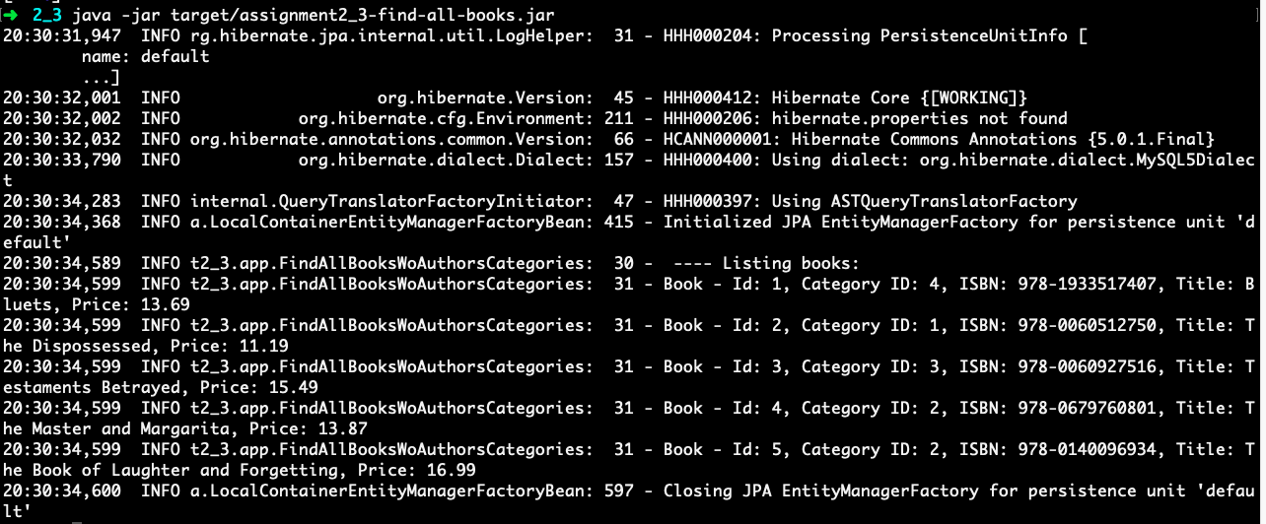

* find all books with authors and categories
  + java -jar target/assignment2_3-find-all-books-w-author-categories.jar
  + expected output (partial):

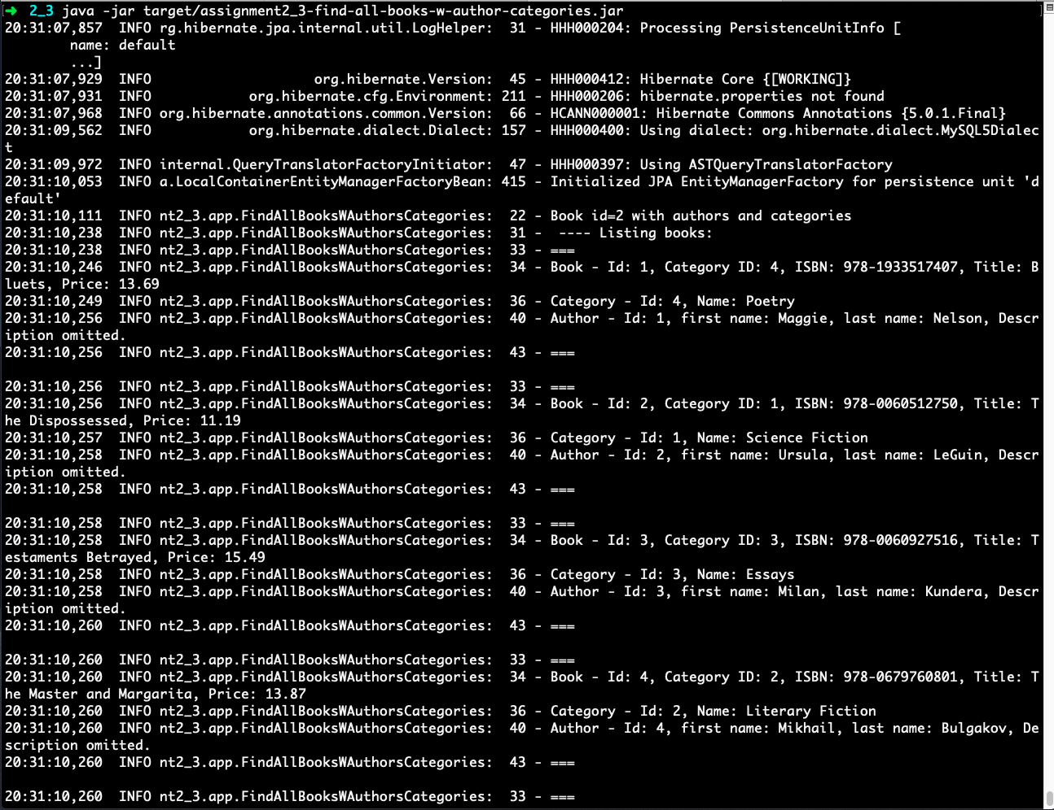

* find a book with authors and a category name by book’s ID
  + java -jar target/assignment2_3-find-book-by-id-w-authors-categories.jar
  + expected output:

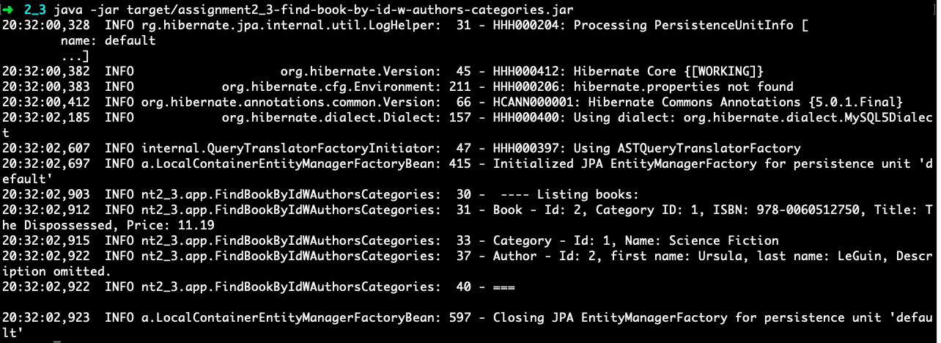

* Create a new book with new author not persisted in database
  + java -jar target/assignment2_3-create-new-book-author.jar
  + expected output:

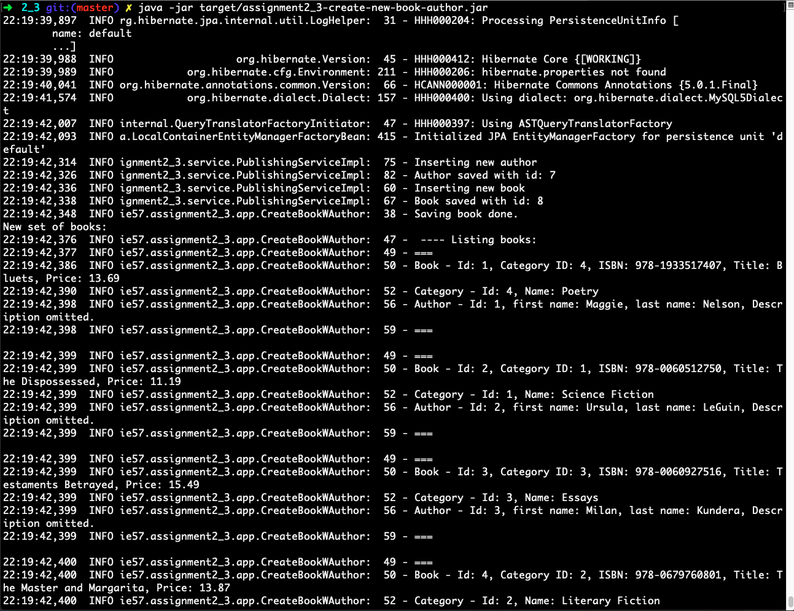

* Delete the saved book and author from database
  + java -jar target/assignment2_3-delete-book-author.jar
  + expected output:

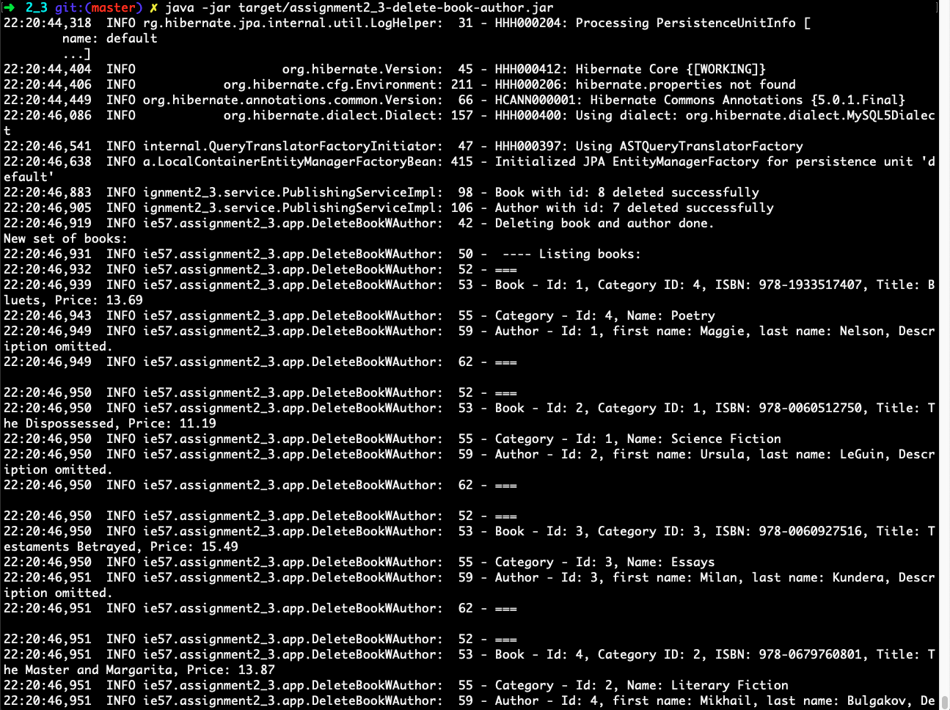

* Find all books for one author id who has more than one book in your database
  + java -jar target/assignment2_3-find-book-multiple-authors.jar
  + expected output:

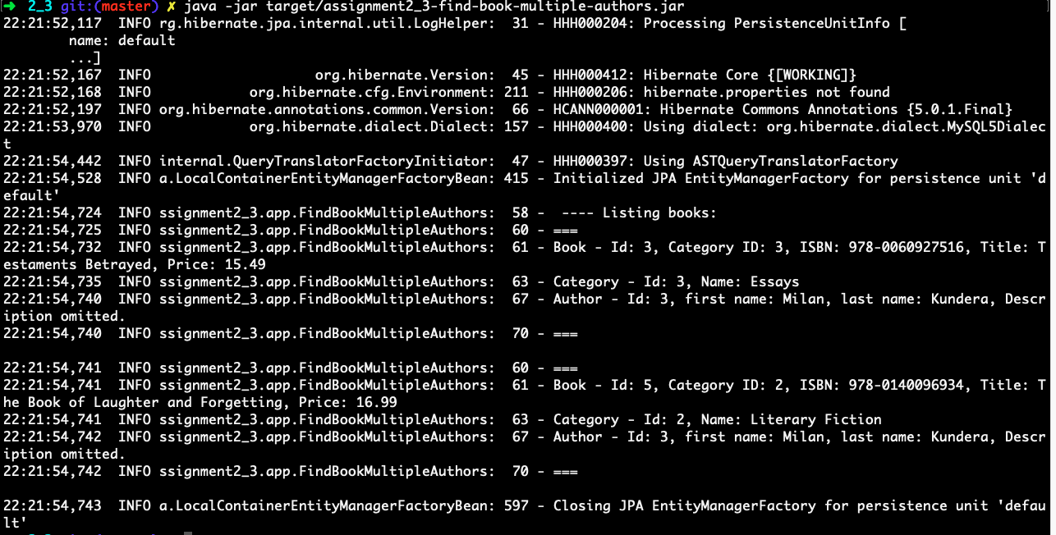

* Find all books by native queries. No authors and categories.
  + java -jar target/assignment2_3-find-book-native-query.jar
  + expected output:

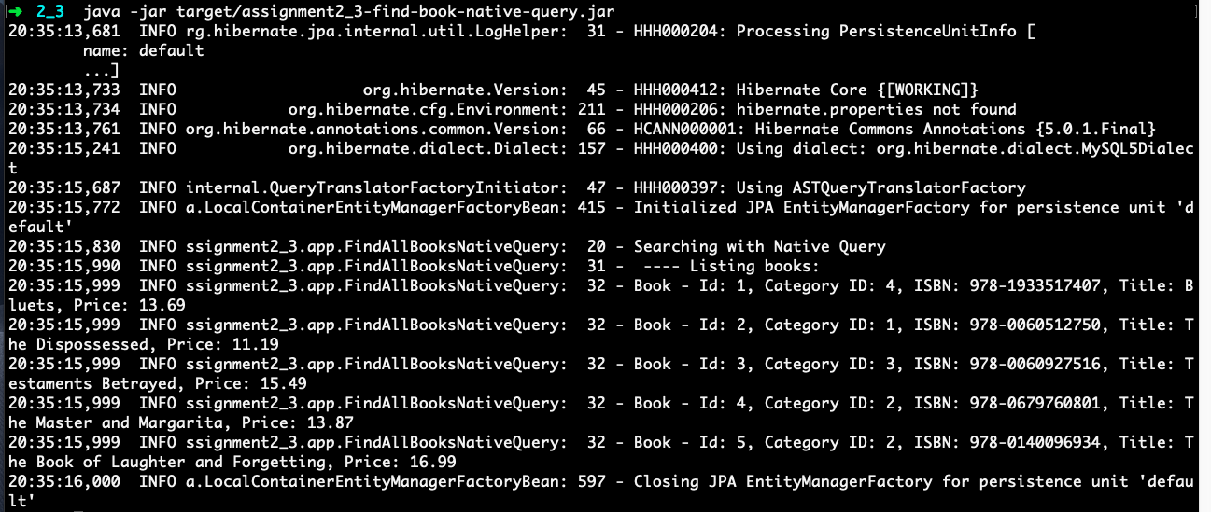

2.4:

Prerequisite: none for MySQL (reuses database from 2.2). Running mvn clean install.

* find a book with author and category by book id:
  + java -jar target/assignment2_4-find-by-id-w-authors-categories.jar
  + Expected output:

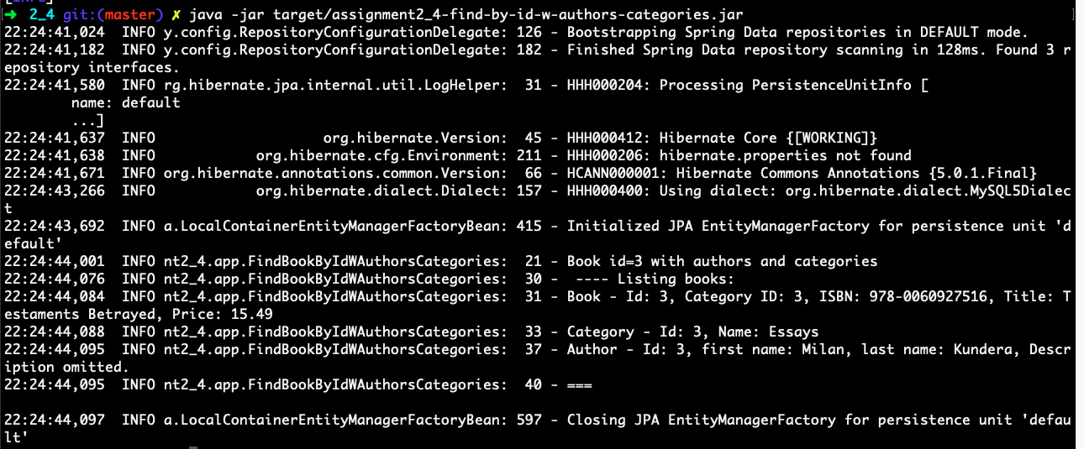

* find all books without details.
  + java -jar target/assignment2_4-find-all-books.jar
  + Expected output:

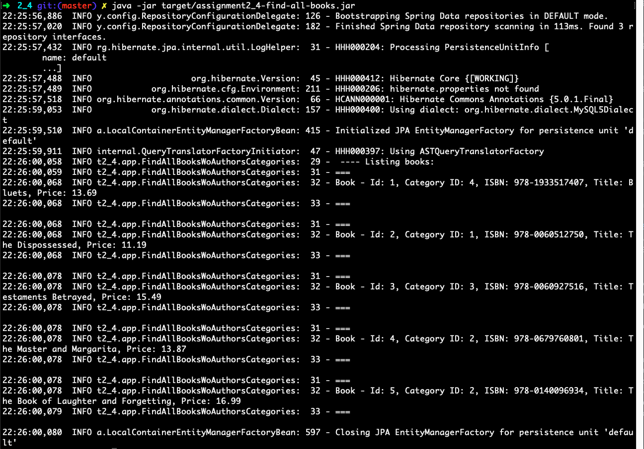

* create a new book with a new author not yet persisted in your database.
  + java -jar target/assignment2_4-create-new-book-author.jar
  + expected output:

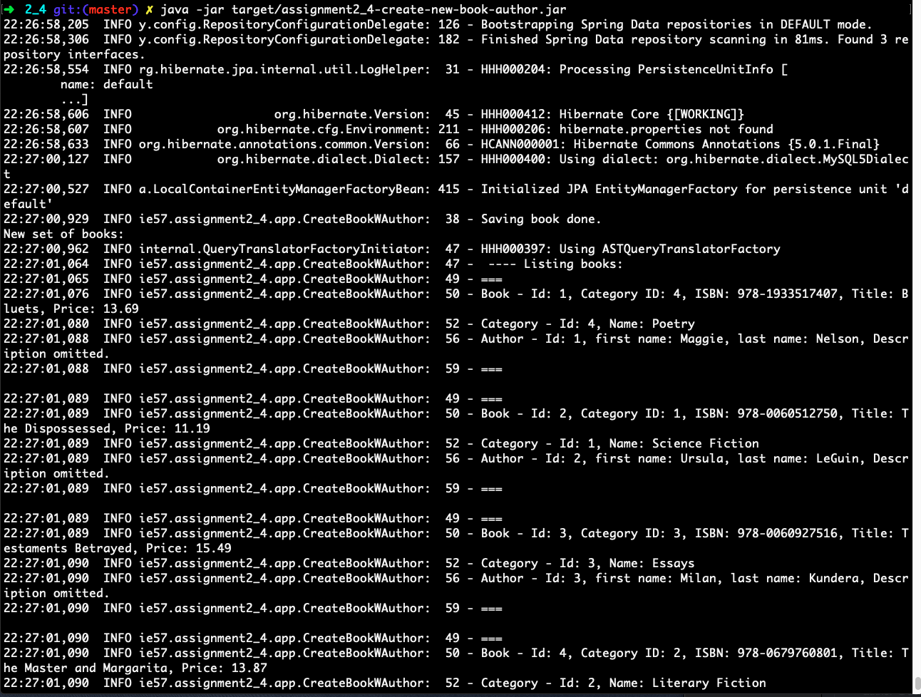

* delete the added book and the author from the database
  + java -jar target/assignment2_4-delete-book-author.jar
  + expected output:

